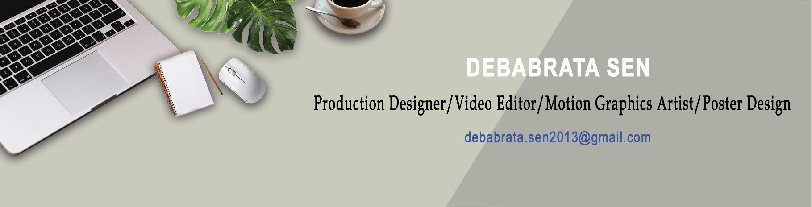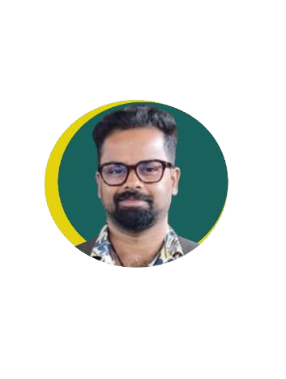

Debabrata Sen

Home Address: Kalyan nagar, Madanpur, Nadia, Pin-741245

Current Address: 109/ D Ramkrisnagar, Garia, Koi-700153 M: +91 7980 576 930 [https://github.com/RintuSen1990](https://github.com/RintuSen1990/Konet-Limited) <https://go.screenpal.com/watch/cZXlIKnVn5j> [https://www.Iinkedin.com/in/debabrata-sen-277561335](https://www.iinkedin.com/in/debabrata-sen-277561335) [Profile | Mynaukri](https://www.naukri.com/mnjuser/profile?id&altresid)

# **Summary**

I have sound academic backgrounds in arts & has longstanding experience/passion in drawing/painting, pandel designing & execution. I have enhanced my production quality & art design by my recent ZICA & ZIMA Course.

I have evolved as a Production Designer through my ZIMA course & my work experience in making 8 short film & Durga Puja pandel for the last 4 years. I have learned & developed as a Motion Graphic Artist & Video editor through my recent course with ZICA & MAAC. It has helped to think of painting beyond 3D concept & also helped to secure/ execute my overseas consultancy work smoothly. I have learned time based project execution & how to align my skills according to my customer's need

# **Professional Training**

[**https://github.com/RintuSen1990/Professional-Technical-Certificates**](https://github.com/RintuSen1990/Professional-Technical-Certificates)

**Course on Compositing & Video editing (MAAC), July 22-Oct 24**

I have recently completed 2.5yrs Course on Compositing & Editing covering video editing, Digital Photography /DigitaI Film making, Motion Graphics (using After effects & Premier Pro), Poster Design, Photoshop, Premier Pro, After Effects (Including Mocha),

**Programme in TV/ Film Production (ZIMA) July 20-March 22 3D Animation (ZICA), Feb 21-June 22**

I have earlier done 2yrs courses on TV/Film Production (focusing on logistics side & production set design) & 3D Animation (Photo Shop, Maya) focusing on model making & animation through Maya.

**Method Paper (Art Education), July 2009-Mar 2010**

I have done this 1 year paper (Theory & Practical) as a part of my B.Ed training on painting, hand craft

**Academic Qualification**

[**https://github.com/RintuSen1990/Education/blob/main/Education%20Certificates.pdf**](https://github.com/RintuSen1990/Education/blob/main/Education%20Certificates.pdf)

**M.Ed-WBUTTEPA, Kolkata, 2016-2018**

**B.Ed- Kalyani University, 2009-2010 MA (History) 2006-2008 BA (Hons) 2003-2006**

**Work Experience**

**Konet Limited, UK, Jan 2021- till now** [**https://github.com/RintuSen1990/Konet-Limited**](https://github.com/RintuSen1990/Konet-Limited)

I have worked as a Project presentation Designer on contractual basis. I was able to take up many roles, such as Poster/Motion Graphics Designer & Video editor. This was a valuable insight into how my skill set can improve quality of my client's digital foot print. I was able to gain many transferable skills in this short amount of time

**Skills and achievements**

1. **Video Editing & Motion Graphics:**
2. **Social Media Advertisement Editing**
3. **Logistic Company Advertisement Editing**
4. **Old Song Mash up**
5. **Movie Trailer Editing**
6. **Creative Poster**
7. **Poster designing**
8. **Theme/creative Durga Puja pandal:** I have been designing & executing theme Durga Puja pandel for last 6yrs including the props. Our Durga Puja Pandel was awarded by News 24 in 2020
9. **Production Designer & Art Direction:** I was involved as a Production Designer & Art Director in 5 Short films & 1 Stop motion film. One of our Short Film (Some moments in Stagnancy) got awarded in 8 Film Festivals.
10. **Digital & Acrylic Painting**

**Portfolios:**

1. Video Editing & Motion Graphics: <https://go.screenpal.com/watch/cTVIolne7o3>
2. Video Editing & Motion Graphics: <https://go.screenpal.com/watch/cTVlFineJU6>
3. Social Media Advertisement Editing: <https://go.screenpal.com/watch/cTVIoUne7qT>
4. Logistic Company Advertisement Editing: <https://go.screenpal.com/watch/cTVIoEne73H>
5. Logistic Company Original Advertisement: <https://go.screenpal.com/watch/cTVIoEne73H>
6. Old Song Mash up: <https://drive.google.com/file/d/1yOwpKO1ren8MdBkhsVo7m_yC50aznl73/view>
7. Jawan Movie Trailer Edited: <https://go.screenpal.com/watch/cTVIoPne7TJ>
8. Jawan Original Movie Trailer: <https://www.youtube.com/watch?v=COv52Qyctws>
9. Creative Poster: <https://github.com/RintuSen1990/Creative-Poster>
10. Poster designing: <https://github.com/RintuSen1990/Creative-Poster>
11. Theme/creative Durga Puja pandal: <https://github.com/RintuSen1990/Theme-Durga-Puja-Pandal>
12. Production Designer & Art Direction: <https://github.com/RintuSen1990/Short-Film>
13. Digital & Acrylic Painting: https://github.com/RintuSen1990/Painting